**NITRI HAND PRODUCT SPECIFICATIONS**

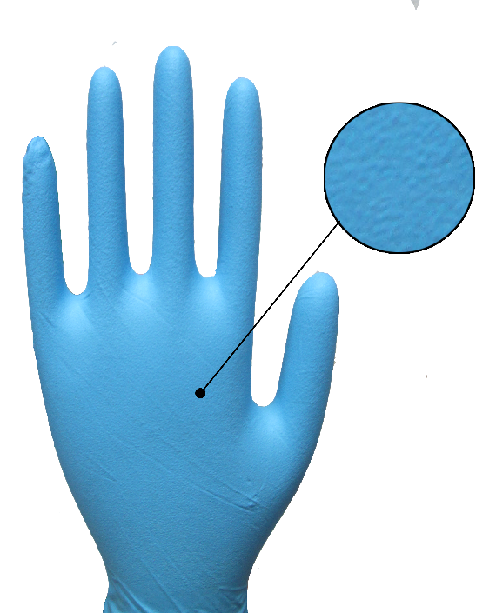**Name of Product** - 4 Mil Powder Free Nitrile Exam Gloves.

**Name of Manufacturer**  - Innovative Gloves Co. Ltd. Hatyai, Thailand.

**Base Material**  - Nitrile.

**Characteristics** -Non-Sterile, Ambidextrous Beaded Cuff.

**Available Sizes** - X-Small, Small, Medium, Large, X-Large, XX-Large.

**Surface** - Textured.

**Surface Treatment** - Polymer Coating.

**Color**  - Blue.

**Total Extractable** - < 2.0 milligram per glove.

**protein content**

**Physical Specifications:**

|  |  |  |  |  |  |
| --- | --- | --- | --- | --- | --- |
| **Size** | **Length(mm/inch)** | **Thickness(mm)**  **Single Wall** | | | **Width(mm)** |
| Tip | Palm | Cuff |
| X-Small | 240±5 | 0.11±0.01 | 0.08±0.01 | 0.06±0.01 | 75±5 |
| Small | 240±5 | 0.11±0.01 | 0.08±0.01 | 0.06±0.01 | 85±5 |
| Medium | 240±5 | 0.11±0.01 | 0.08±0.01 | 0.06±0.01 | 95±5 |
| Large | 240±5 | 0.11±0.01 | 0.08±0.01 | 0.06±0.01 | 105±5 |
| X-Large | 240±5 | 0.11±0.01 | 0.08±0.01 | 0.06±0.01 | 115±5 |
| XX-Large | 240±5 | 0.11±0.01 | 0.08±0.01 | 0.06±0.01 | 120±3 |

**Tensile (ASTM D412 & EN 455-2)**

**Before Aging**

|  |  |  |
| --- | --- | --- |
| **Tensile(MPA)** | **Elongation(%)** | **Force At Break(N)** |
| 22 Mpa Min. | 500 Min. | ≥ 6 N |

**After Accelerated Aging**

|  |  |  |
| --- | --- | --- |
| **Tensile(MPA)** | **Elongation(%)** | **Force At Break(N)** |
| 22 Mpa Min. | 500 Min. | ≥ 6 N |

|  |  |
| --- | --- |
| **Total Residue Content** | < 2.0 Milligrams per glove. |
| **Packaging (Normal)** | 100±2 pieces in one Dispenser Box,10 Dispenser Box in one Carton. |
| **Labeling on Dispenser (Normal)** | Product Name, Size, Lot no. Quantity, Manufacturer’s address. |
| **Labeling on Carton (Normal)** | Product Name, Size, Lot no. Quantity, Country of Origin. |

**Container Loadability** (No MOQ in manufacturer owned brand in standard Packaging)

|  |  |
| --- | --- |
| 20 FCL=1360 Cartons. | 40 FCL=2740 Cartons. |

,

**Certification**

A screenshot of a cell phone

Description generated with very high confidence